Breadth-First Search (BFS) — Without Queue & With Queue

Overview:
Breadth-First Search (BFS) is a fundamental graph traversal algorithm that explores nodes level by level. It starts from a given node (known as the root or start node) and visits all the neighbors before moving to the next level of nodes.
There are multiple ways to implement BFS:
- Using a Queue: The most common and iterative method.
- Without Queue: A recursive approach that uses lists to manage levels instead of a queue.
Both methods perform the same logical process — they visit nodes in breadth-first order — but use different structures to manage traversal.

1️⃣ BFS Without Queue & Without Node

Code Explanation:
- The graph is represented using a dictionary where keys are nodes, and values are lists of connected nodes.
- The function bfs_without_queue() takes a list of nodes at the current level.
- If the list is empty, recursion stops.
- For each node in the current level:
- The node is printed.
- Its neighbors are added to a new list (next_level).
- The function is called again recursively for next_level.

Code:
- graph = {
'A': ['B', 'C'],
'B': ['D', 'E'],
'C': ['F'],
'D': ['G', 'H'],
'E': [],
'F': ['I', 'K'],
'G': [],
'H': ['L'],
'I': [],
'K': ['M'],
'L': [],
'M': []
}
def bfs_without_queue(current_level):
if not current_level:
return
next_level = []
for vertex in current_level:
print(vertex)
for neighbour in graph[vertex]:
next_level.append(neighbour)
bfs_without_queue(next_level)
# Starting BFS
start = ['A']
bfs_without_queue(start)

Output:

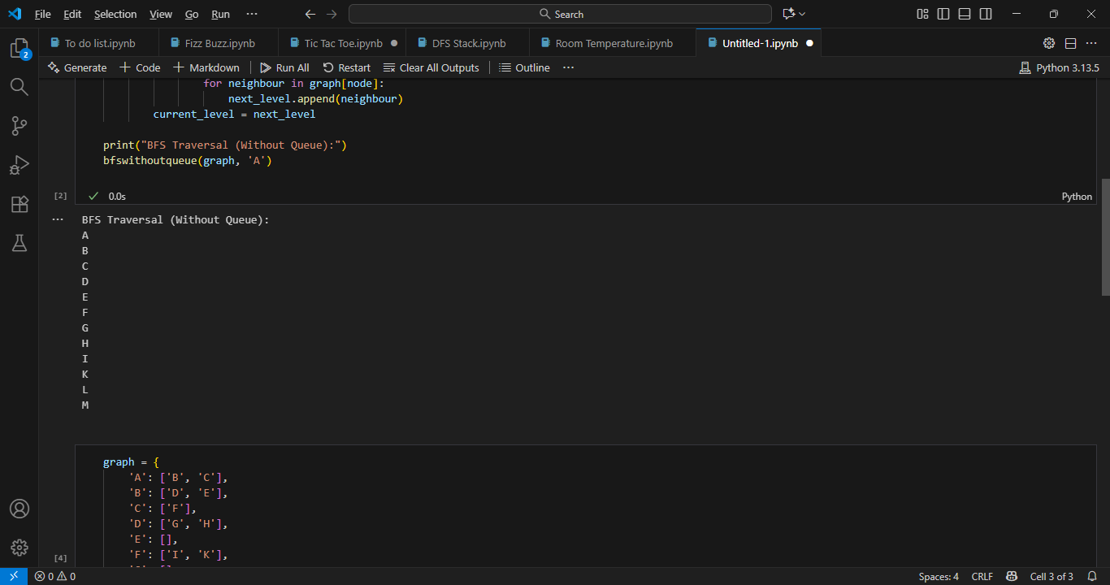

2️⃣ BFS With Queue & Node

Code Explanation:
- This version uses a queue to store nodes that need to be explored.
- A node is removed from the front of the queue (FIFO principle).
- Its unvisited neighbors are added to the queue.
- This ensures that nodes are processed in the same breadth-first order.

Code:
- graph = {
'A': ['B', 'C'],
'B': ['D', 'E'],
'C': ['F'],
'D': ['G', 'H'],
'E': [],
'F': ['I', 'K'],
'G': [],
'H': ['L'],
'I': [],
'K': ['M'],
'L': [],
'M': []
}
from collections import deque
def bfs_with_queue(start):
visited = []
queue = deque([start])
while queue:
vertex = queue.popleft()
if vertex not in visited:
print(vertex)
visited.append(vertex)
for neighbour in graph[vertex]:
queue.append(neighbour)
# Starting BFS
bfs_with_queue('A')

Output:
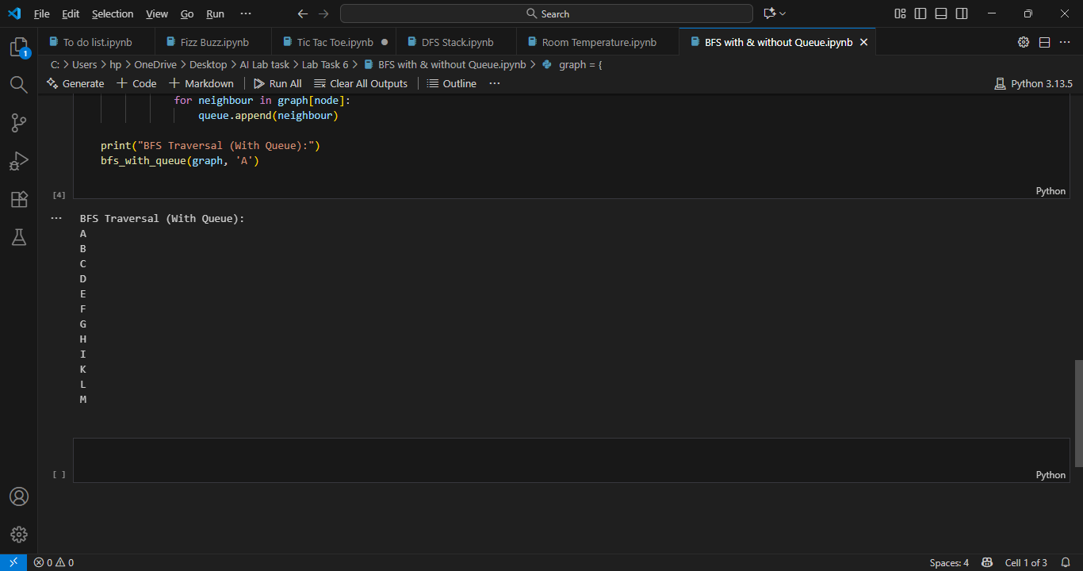

Final Discussion: Why Both Outputs Are the Same
Both implementations are performing Breadth-First Traversal, which means visiting all nodes level by level. Even though their implementation style is different — one uses recursion while the other uses an explicit queue — their logical process is identical.
Aspect | Comparison
Storage used | Recursion & lists vs Queue (FIFO)
Traversal order | Level by level
Output difference | None
Reason:
Both methods process nodes in the same order, since BFS depends only on the graph structure and neighbor order, not on whether you use recursion or a queue.
Can their outputs ever differ?
Yes, but only if:
- The order of neighbors in the graph dictionary changes.
- A condition is added to skip or prioritize certain nodes.
Otherwise, both approaches will always produce the same BFS traversal output.

